Table of Contents
Getting started 1
Discover 1
How to Search Data 1
Dashboard 1
How to Create a Dashboard 3
Visualize 6
How to Create a Visualization 7
Anomaly detection 10

Getting started
Brief Introduction to Elasticsearch
This cluster is where visibility is going to be provided for anything running in aws.
So, before we begin the document attached is a high visibility architecture diagram of what has been deployed in aws gov-cloud east and west.
Why Elasticsearch?
- This is going to be the aws cls logging solution for all data sources that will be a hub and spoke model to provide visibility to external teams for example csoc being the primary one right now , Splunk is their normal tool from on prem incident response and incident handling.
- The log data is being queried and from those query’s they are alerting from those data flows.
- Aws cloud does not have that visibility with Splunk so there is some limitation for taking log data from aws and steaming that log data on prem.
- there are charges for when data leaves the cloud there is a chargeback to that account from where data is leaving from.
- There’s overhead moneywise if you try to send data to an on prem Splunk setup.
- So, solution was to keep log data in the cloud to avoid those charges while giving project teams a way to do correlations between all different sources of log data
- Answer (that’s some of the issues we have going on, many tools are doing this on what tools should do alerting and monitoring. This log solution is to meet your ato requirements for centralized logging. So if you go through there is an audit family for your ato based of the nisp 800-53 policy there’s like 300+ audit checks and those audit checks are what determine what these alert types mechanisms that we need to be notified of from that policy. For example, a local user added to Linux. that’s an audit event because you want to know if somebody is adding a local Linux user to a Linux box because that violates your policy for 2f authentication. alert on many things.

Understanding Elasticsearch
- It’s a full elk cluster with Logstash being the ingestion point for many other log sources.
- Those ingestion points require log shippers installed on the guest operating system called installed ElasticSearch beats agents
- . (stay on awslogs index) we also have a data flow diagram that we then break down by data source from a start point of how a Linux log will make its way into the cluster when you are onboarding into the logging solution.
- When your account is onboarded there’s a CloudWatch rule that will gather every log which also can include CloudTrail logs additional with CloudWatch groups whatever have been created can subscribe to cwl index. The awslogs is more so for your aws account audit events.
- What’s happening whose logging in whose doing what calls are being made.
- Every one of these are different log indexes created for different log sources.

What is the Kibana Interface?
Kibana is a tool that tightly integrates with Elasticsearch making up a third of the ELK stack. 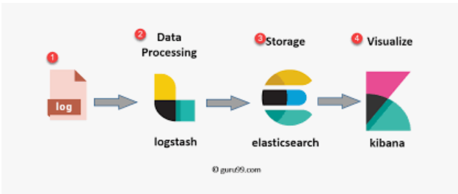
Which consists of Elasticsearch, Kibana, and Logstash. Kibana is the interface that allows you to view your Elasticsearch data. Within the Kibana interface we are going to focus on the some of its key features located in the side navigation plane within the interface. In the further paragraphs we will list out these features and give a brief overview of each one to the degree of ensuring usability to the end-user. The features which will be referenced are Discover, Visualize, Alerting, and Anomaly Detection.

Discover
Overview
The Discover data section is a welcome addition to since Kibana 4.0. This section is where you can find your ElasticSearch data. It allows you to search and filter through that data to be able to look through your data deeply
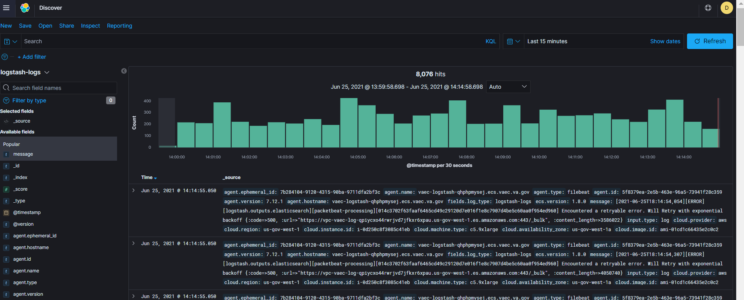
Essentially the most powerful part of the discover page is its querying ability: the ability to combine free text searching capability in addition to filtering, based on structured data.

How to Search Data
To search your data, you must execute a query against an index.
An index is thought of as a collection of documents and a query is an action performed against an index to obtain specific data or information.
Before Executing Search
Before executing a search, you must first make sure you are on the Discover tab of the user interface. If you are not please navigating to the discover section of the user interface and select the index pattern that you would like to perform your query against from this screen.
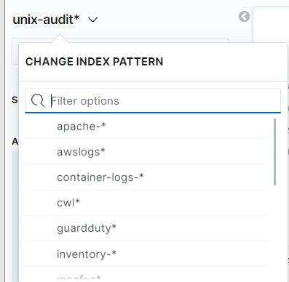

There are 13 index patterns currently and the data they supply
- Apache: httpd log data
- Awslogs: AWS log data
- Container-logs: docker container log data
- Cwl: CloudWatch log data
- Guard duty: Guard duty log data
- Inventory: ec2 inventory documents
- MacAfee: contains MacAfee log data documents
- Metrics: contains system metric data log documents
- Packetbeat: contains network traffic data log documents
- Unix-audit contains auditd log data documents
- Unix-system contains system level log data documents
- Win-log: Windows server data log documents
Elements of the search bar
The search bar is where you will input your query and it is where you will specify the time range to search in your data.
There are 4 components that make up the search bar.
- Saved Queries: You have the option to save your queries. When you would like to this is where you can perform the query saving action and this too is where you can view all saved query’s
- Search Field: This is where you type your search query
- Syntax Options: This is where you choose your language interpreter option. You can choose between KQL (Kibana Query Language) or Lucence. KQL is the selection by default
- Date selection: This is where you will specify the time range you would like to perform your query against

Types of Searches
When it comes to searching your data there are 3 core search types: free text search, field level search, and filter search.
Free text search:
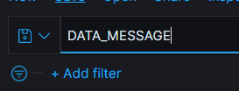
- Free texts search is the simplest search when used.
- It is performed against all index fields including the _source field.
- This also makes it the less performant as compared to the field level search.
- If there are no specific fields entered the search will search all fields. Free text searches are not case sensitive unless you use double quotes. Example: apache is up
Field level search:
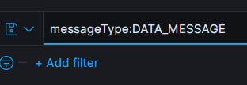
- This type of search allows you to search for a specific value mapped to a specific field.
- More performant and accurate than free text searching.
- Example: uptime:
- What is required is to add the name of the field as a prefix to the value you would like to search for.
- The results will limit the results of documents containing these responses but using field level searches also depend on the field type
- Wild card searches cannot be used for non-analyzed fields. Searches are case sensitive and must be an exact match.
- There’s a lot and this is just on the aws index.
- By selecting the key, you can see the top values within each field, and you can create a filter that way.
- When you want to be more specific you can look at detail. event name
- . clicking plus or minus not add You filter on assumed roles.
- It highlights what it finds within the logs and it filters it from the search.
- The data changes based on the configured timing.
- in the last 15 minutes this is what has happened.
- What is displayed is a rollup of the log but if you click to expand the document you can get a table of the log or you can get the data in json format of all of the specifics of that event.
- You can see all the fields. Not all fields will be populated unless it pertains to the data source.

Filter Search:
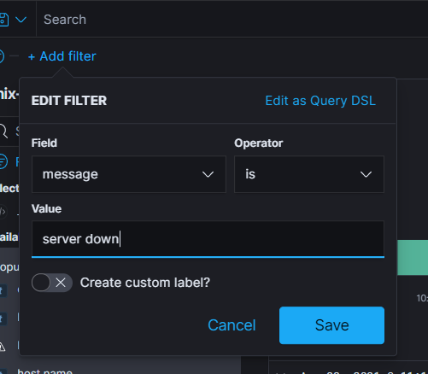
- This is a visual way in which you can interact with your data.
- You can create conditional filters based on the fields you have in your logs.
- The available conditionals are as follows: (is, is not, is one of, is not one of, exists, and does not exist).
- In the above example a filter is created against the message field to find values that are equal to “server down”.
Advanced Search Techniques

Booleans Queries - Allows you to perform queries with or, and, and not
Example: response:100 or response:300
Range Queries –
Exist queries – query that matches all document values to a specified field.
Example: host.name: *
Wildcard Queries - search term that allows you to search for a term prefix to search for multiple fields or this can be used to search multiple values for a field
Example: antitype’s*

For more information about searching please visit https://www.elastic.co/guide/en/kibana/master/kuery-query.html

Dashboard
Basic Dashboard Documentation
- The basic dashboard documentation serves as an intro guide to gaining familiarization with creating Kibana dashboards
- In this guide the user will learn
  - What is a dashboard
  - What is a visualization
  - How to create both a dashboard and visualization
- Along with
  - Additional references for familiarization.
Prerequisites
- Secure an index in mind you would like to use to feed your dashboard
  - An index is thought of as a collection of documents and a query is an action performed against an index to obtain specific data or information.\
- Secure or have a search query in mind you would like to create a dashboard from
  - To search your data, you must execute a query against an index.
  - In addition, dashboards can be created from your saved queries
- Secure the visualizations to use
  - Since visualizations are the core components which make up your dashboards they must be created first before you generate a dashboard or you will have the option to create a visualization in real time as you are creating your dashboard.
For more information about the tasks above at hand please consult the Query Reference Documentation If you have not already done so.
What is a Dashboard
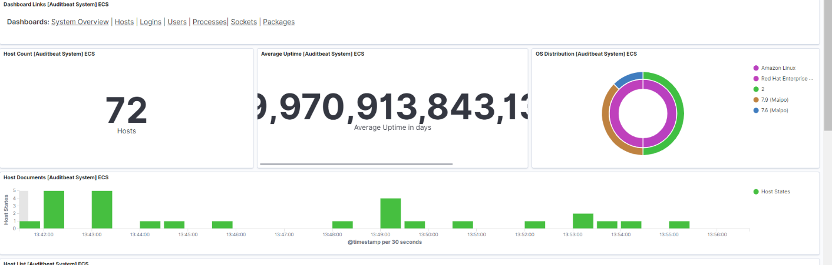
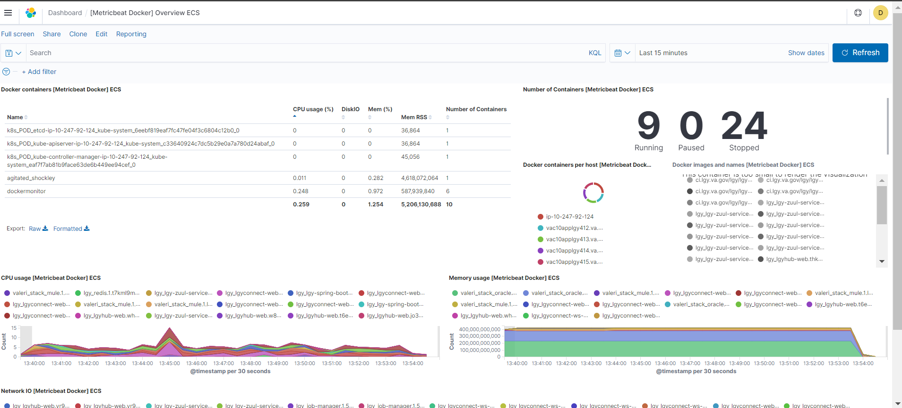
- A Kibana dashboard is a graphical user interface which provides data briefly by use of visualizations created from one or more index patterns.
- Kibana dashboards are dynamic by nature
  - Data comes in at real time from Logstash and whatever reports are created in the dashboards will be updated from the new data that is being generated.
Reference Information and Material
- For additional reference information please visit the elastic.co documentation for dashboards

How to Create a Dashboard
- Click “Dashboard” from the menu dropdown
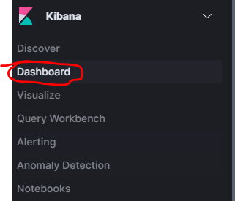
- Click the “Create dashboard” button
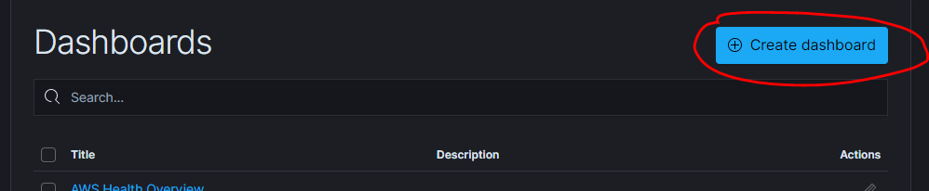
- You should be now at your dashboard default configuration page
  - You should have the option to add visualizations, they will be added in the form of panels.
  - As stated before, to create a new visualization by clicking the “Create new” button or you can add an already existing visualization by clicking the “Add an existing” button
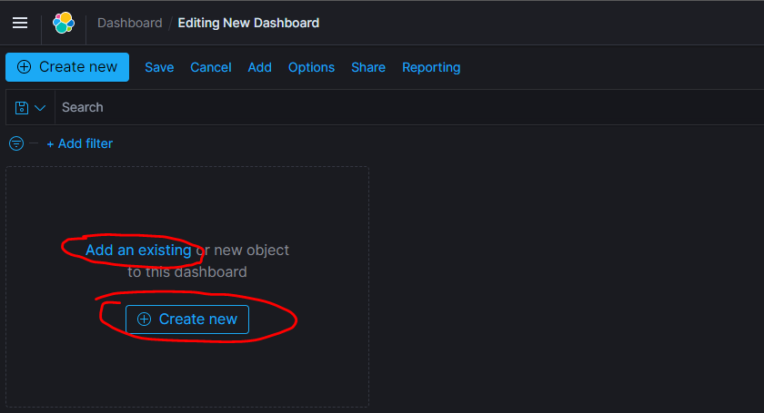
- When selecting from the already existing visualizations each click will add the corresponding visualization into your dashboard visual at glance
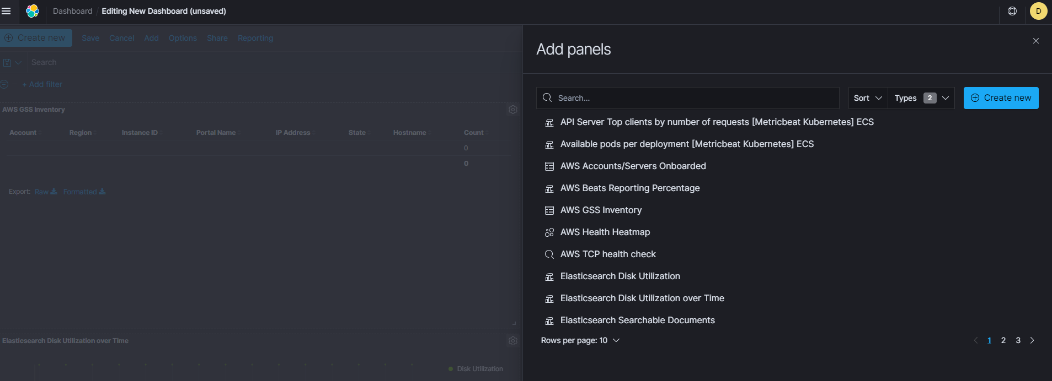
- When you have the desired visalizations contained in your dashboard, and arranged in an aestethical manner of your approval please click save to save your dashboard.
  - Upon saving you will have the opportnity to give a name to your dashboard
  - You will also have the option to select “store time with dashboard” which makes it so whenever you access yoru dashboard the current time filter in place used while at dashboard configuration will be used whenever the dashboard is access going forward
- 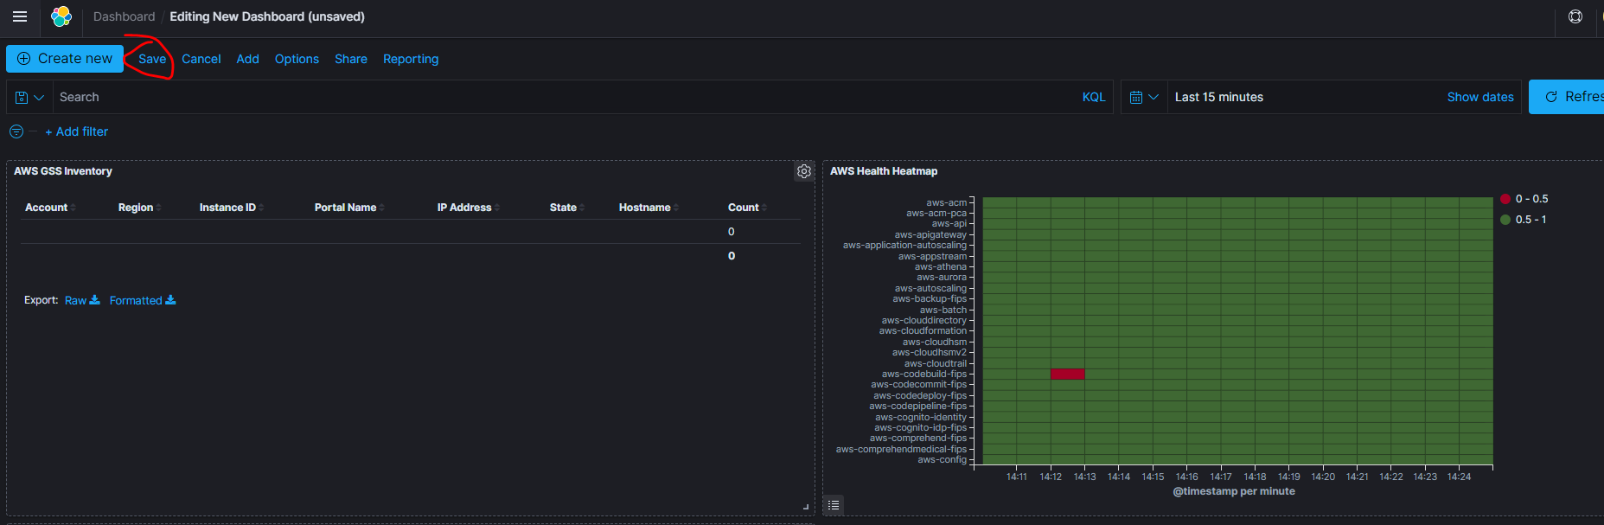

Overview
- These dashboards – aws health dashboards monitor all apis in a nice heat mat. We have had aws fips go up and down, we would get ta trigger from an api that’s not available just for an fyfi so we can let customers know what’s going on
How to Create a Dashboard
Existing Dashboards
- Gss inventory is the automated inventory that assists with your emas entries. Here as you can see it’s at the account level and Donovan develops lambda functions that pull a lot of information into this one view. You have the hostname ips address, os what account it’s in, instance, name, size, the running state aim id and etc. within this dashboard you can check overtime to see when instances have dropped or have been added. This can be exported also.
- Guardedly inventory- is the security-based information. These are different data about threat types monitored by guard duty.
- And below are the top 10 findings of guard duty findings. Based on what’s happening on each one of the ec2 on that account
- Then down here we have the heat map of where information is coming from. On the second map when you click on Russia it will drill on the data that is coming from that country. When you scroll up to the top you can see the top 10 findings against the instance id.
- Heartbeat http monitoring – is certificate data was 443 it would be shown here and as similar as the
- Heartbeats monitor. – this supports the other aws api’ s.
- Privilege escalation: one we were looking at within aws we have the ability to use sessions manager when you have system manger agents installed within ec2s. for Linux you would be able to escalate your privileges by using sessions manager which is not bypassing the epas process. We are alerting on anyone who is trying to privilege escalate as root using sessions manager when they are not cleared by the epas system of approval.
- Windows dashboard. This is dashboarding from win log beats agent. We have number of events, number of events by channel, ecs, the top 10 event ids, you can change the event id by clicking the plus to change the source. You can get the log file data by adding a data table at the bottom. It’s not configured that way by default. This will show system logs security logs and application logs

- Metric beat system overview ecs – tis gives you an overview of the hosts being captured into the dashboard such as cpu utilization disk utilization, inbound traffic, it’s all a snapshot of what’s happening on your system. The top 10 by memory of instance what is taking memory.
- Click on hostname will take us to the other dashboard of the specific server (metric beat system | host overview ecs

- This is the visualization, but you can investigate the log data. You can see what processes are taking the most cpu utilization and memory.
- Some of the metrics will not show up because they are not reported by windows the average system load is not supported by windows.
- From Packetbeat overview you can go to the other ones. This one you can see high-level use of dns transactions. This is to collet network like traffic to and from your guest os. You can track http and tls transactions by type. You can select flow type response times. You can use this for troubleshooting, if you see latency you can adjust timeframe to zero in on time events occur.
- Select Packetbeat flows- show what this shows
- The Packetbeat tls sessions ecs, scroll to the bottom to view tls cert information. In this log data captures the certificate and when they expire. If you have certs running on the servers, you can monitor and get alerts 30 days in advance so you can request new certificates.

Visualize
What is a Visualization
- Visualizations are formed from Elasticsearch query results and are the best way to see and understand your data
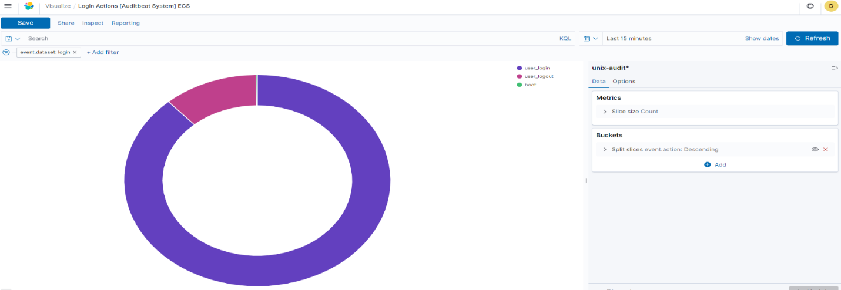
- The Visualize section in Kibana allows you to take your Elasticsearch data and parse it to however way you want to display it. The data is displayed in a table format and if you wish you can export your visualization into (types of csv files) and then you can export it
These results are then extrapolated and used to create charts, data, and maps.

- As included above and not limited to there are 4 types of visualizations
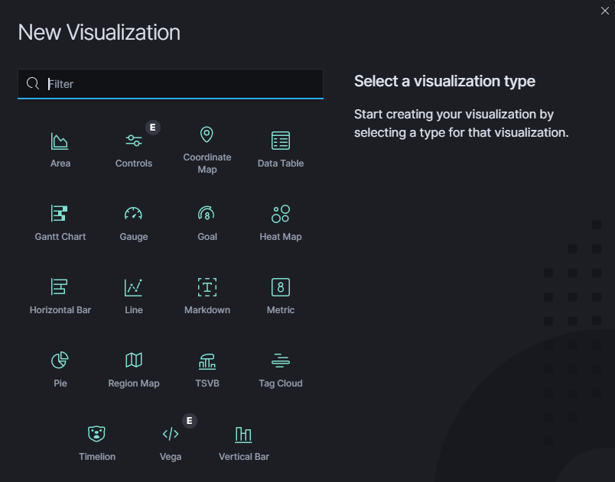
- Basic charts
  - Area
  - Heat Map
  - Horizontal Bar
  - Line
  - Pie
  - Vertical Bar
- Data
  - Data table
  - Gauge
  - Goal
  - Metric
- Maps
  - Coordinate map
  - Region Map
- Time Series
  - Time lion
  - Time Series Visual Builder (TMVB)

How to Create a Visualization
Steps to creating a visualization reports and graphs
- Click Visualize from the Menu Bar
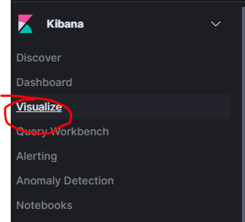
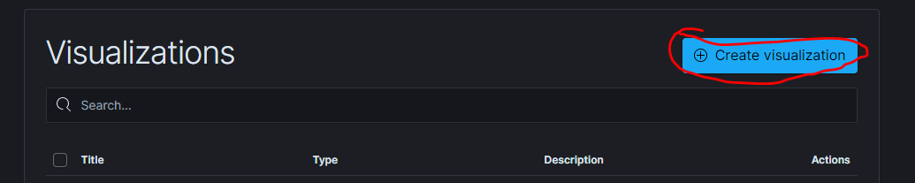
- Click Create new visualization

- Choose your visualization type from the options that are presented and mentioned above in this document.

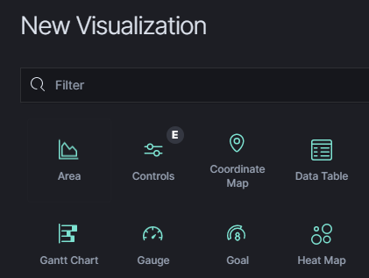
- Specify the Index you will like your visualization to use (for information on all indexes please see the Query Reference Documentation)
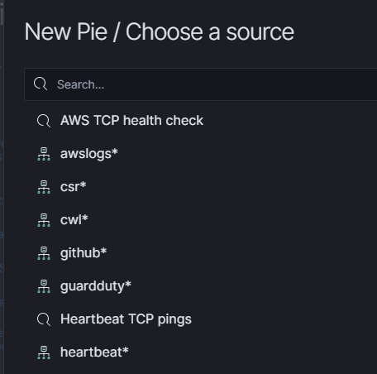

- Now that you have your basic visualization generated, specify the query you would like to filter and extrapolate the data your will like to feed into your visualization. As mentioned, a new search query can be applied, or you can select an already saved query.
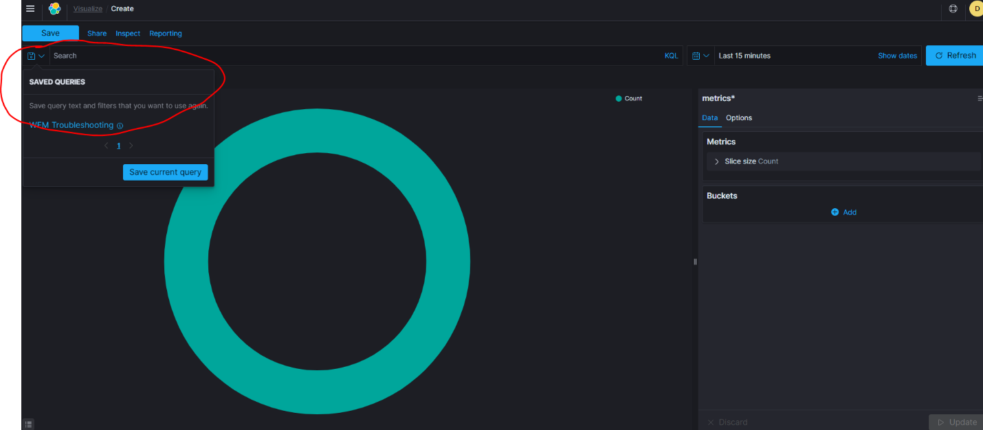
  - Extra note: by default, visualizations that are created from saved searches update congruently if there are any changes to the saved query being used.

Anomaly detection
What is Anomaly Detection?
- Anomaly Detection is a feature in Kibana that allows you to visualize and detect unusual behavior of your data in almost real time.
- An anomaly is (n) something that deviates from what is standard, normal, or expected. Having anomaly detectors can assist with recognizing unusual activity and usage on your server.
- Anomaly Detection in Kibana will look for anomalous activity so you can monitor and create alerts based on these anomaly’s found in examples such as your servers cpu, memory, disk, login failures.
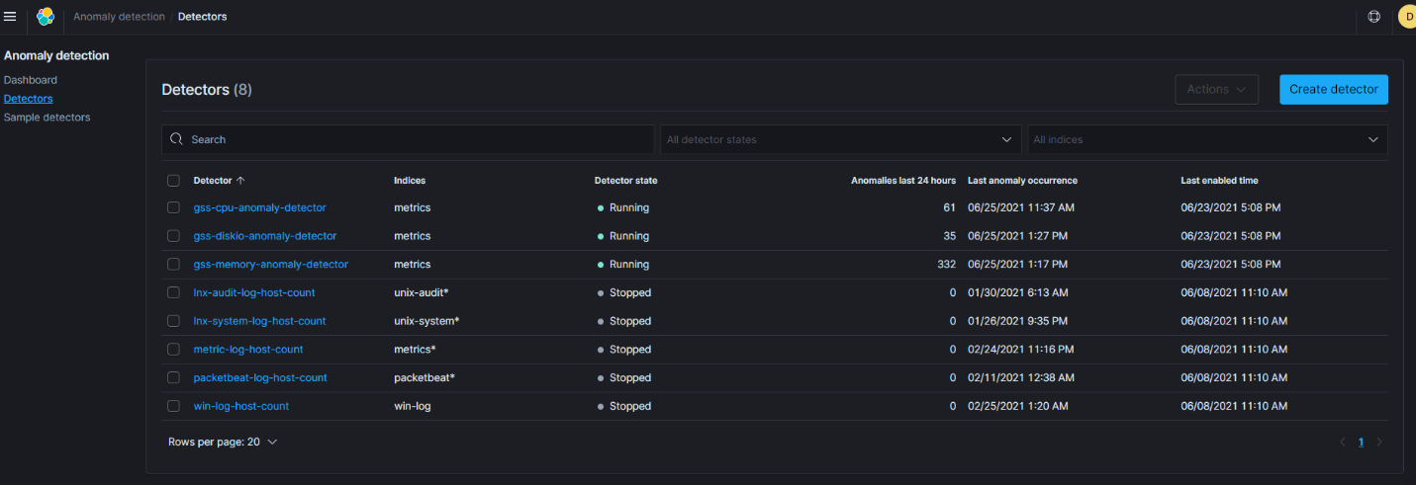
- As you see we have created quite a few anomaly detectors that can be shared to your tenant. There is a total of 10 as labeled in the image above.
- When created you can modify and alert using a different distro list that you want a person to get notified of anomalies. So far, we have _ the anomaly detectors will take data points over a specific data sets, so the algorithm trains itself from the data to determine which events are anomalous based on previous recorded data.
How anomaly detectors work
- Anomaly Detection works by using the Random Cut Algorithm, an unsupervised machine learning algorithm that models a diagram of your incoming data.
- From that data the algorithm computes an anomaly grade and a confidence score value to each of the incoming data points. the anomaly detectors will take data points over specific data sets, so the algorithm trains itself from the data to determine which events are anomalous based on previous recorded data.
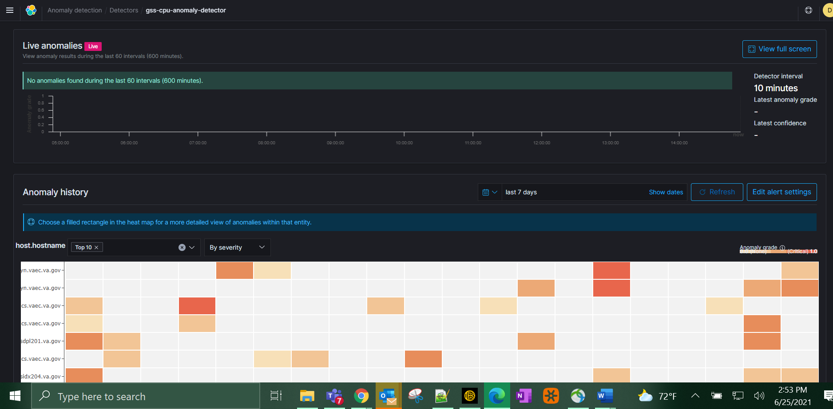
- It is very useful when you want a variation, look for anomalous activity so you can monitor and create alerts based on cpu, memory, disk, login failures,
  - Keynote: If you’re a math aficionado, the machines learning algorithm running for this is using the random cut forced algorithm.

